Star schema
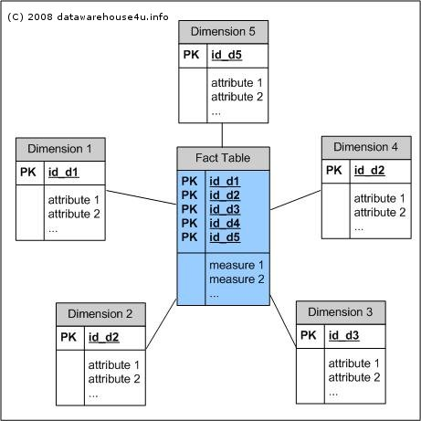
What is star schema? The star schema architecture is the simplest data warehouse schema. It is called a star schema because the diagram resembles a star, with points radiating from a center. The center of the star consists of fact table and the points of the star are the dimension tables. Usually the fact tables in a star schema are in third normal form(3NF) whereas dimensional tables are de-normalized. Despite the fact that the star schema is the simplest architecture, it is most commonly used nowadays and is recommended by Oracle.
Fact Tables
A fact table typically has two types of columns: foreign keys to dimension tables and measures those that contain numeric facts. A fact table can contain fact's data on detail or aggregated level.
Dimension Tables
A dimension is a structure usually composed of one or more hierarchies that categorizes data. If a dimension hasn't got a hierarchies and levels it is called flat dimension or list. The primary keys of each of the dimension tables are part of the composite primary key of the fact table. Dimensional attributes help to describe the dimensional value. They are normally descriptive, textual values. Dimension tables are generally small in size then fact table.
Typical fact tables store data about sales while dimension tables data about geographic region(markets, cities) , clients, products, times, channels.
The main characteristics of star schema:
- Simple structure -> easy to understand schema
- Great query effectives -> small number of tables to join
- Relatively long time of loading data into dimension tables -> de-normalization, redundancy data caused that size of the table could be large.
- The most commonly used in the data warehouse implementations -> widely supported by a large number of business intelligence tools
Snowflake schema
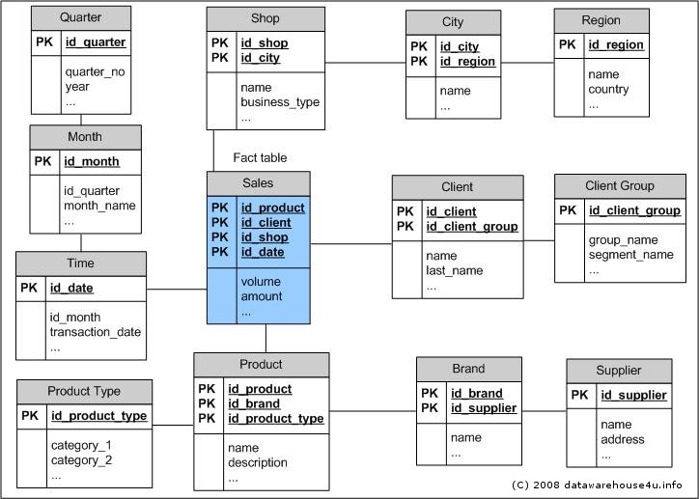
What is snowflake schema? The snowflake schema architecture is a more complex variation of the star schema used in a data warehouse, because the tables which describe the dimensions are normalized.

Fact constellation schema
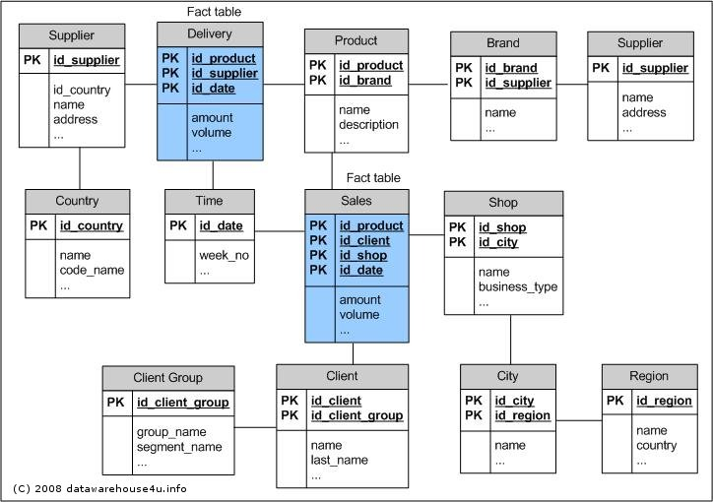
What is fact constellation schema? For each star schema it is possible to construct fact constellation schema(for example by splitting the original star schema into more star schemes each of them describes facts on another level of dimension hierarchies). The fact constellation architecture contains multiple fact tables that share many dimension tables.
The main shortcoming of the fact constellation schema is a more complicated design because many variants for particular kinds of aggregation must be considered and selected. Moreover, dimension tables are still large.

http://datawarehouse4u.info/Data-Warehouse-Schema-Architecture.html

